**<<Mobile shop>>**

**Software Requirement Specification**

– HCM, Mar 2023 –

**Table of Contents**

I. Overview 3

1. Introduction 3

2. System Functions 4

3. Common Requirements 5

II. Functional Requirements 6

1. <<Feature Name 1>> 6

a. <<Function Name 1>> 6

b. <<Function Name 2>> 6

2. <<Feature Name 2>> 6

# I. Overview

## 1. Introduction

My project is about mobile selling website. It includes user login functions to buy and sell products and update product prices, remove products when not in use.

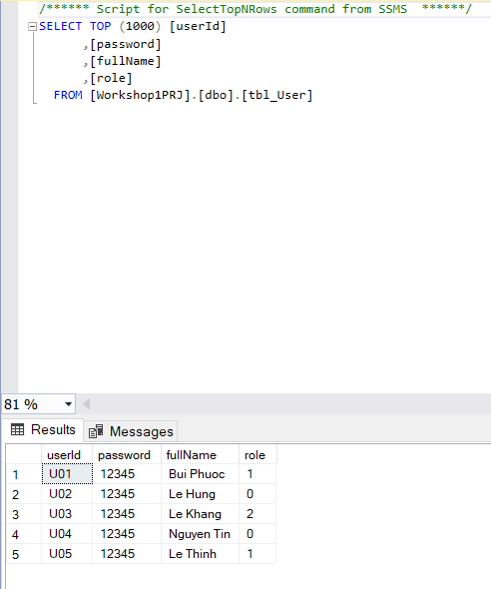

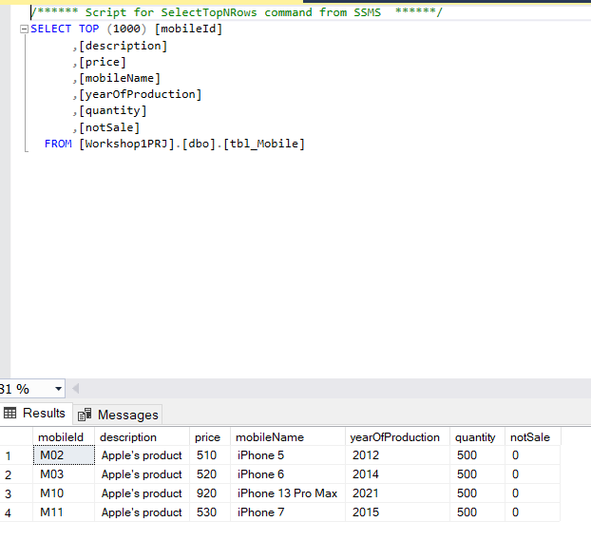>>

## 2. System Functions

#### a. Screen Flow

*[This part shows the system screens and the relationship among screens. You can draw the Screens Flow for the system in the form of diagram as below]*

#### b. Screen Details

*[Provide the descriptions for the screens in the Screens Flow above]*

***b.1 User Wed Application***

|  |  |  |  |
| --- | --- | --- | --- |
| **#** | **Feature** | **Screen** | **Description** |
| 1 | Login account | Login page | Contains text box to input username and password, login button |
| 2 | Get list of milk tea | User Page | List of mobiles, add to cart button |
| 3 | Get mobile detail | Staff Page | Contains mobile details about mobile information, quantities textbox |
| 4 | View cart | ViewCart Page | Contains the items user recently added, payment methods list, Accept order button |
| 5 | Check out | Check out page | Thanking the user for buying and a back to shopping button |

* …

# II. Functional Requirements

## 1. Login

* Function trigger: Starting page
* Function description: The system allows users to use their username and password to log in to the system as customer
* Screen layout:

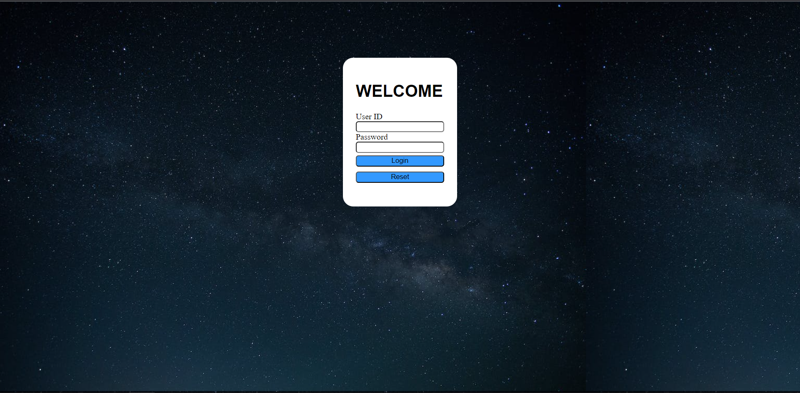

## 4. Search Mobile by name

* Function trigger: after choose Name of Mobile then clicking search button
* Function description: Display mobile according to user’s search request
* Screen Layout:

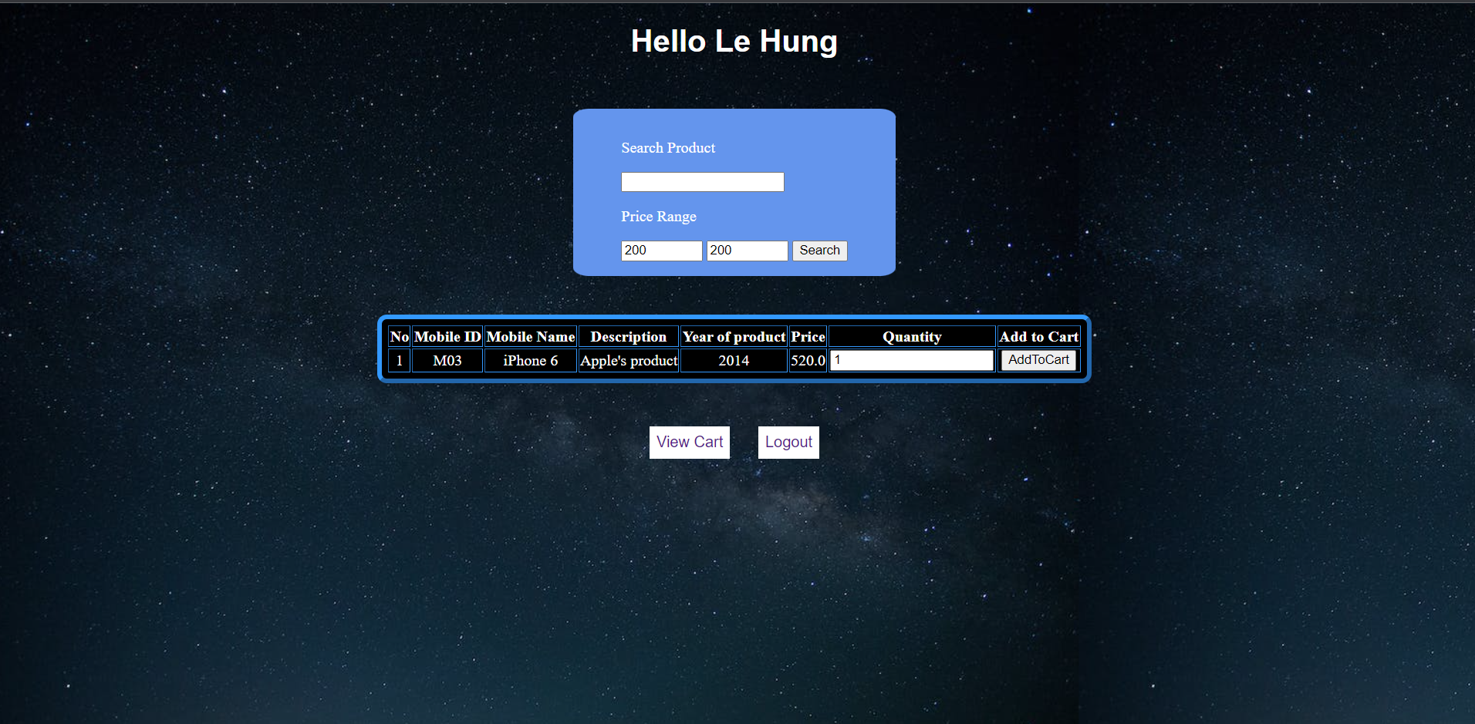

## 5. Show list of mobile

* Function trigger: press search with big price range (200-2000)
* Function description: show list of available mobile
* Screen layout:

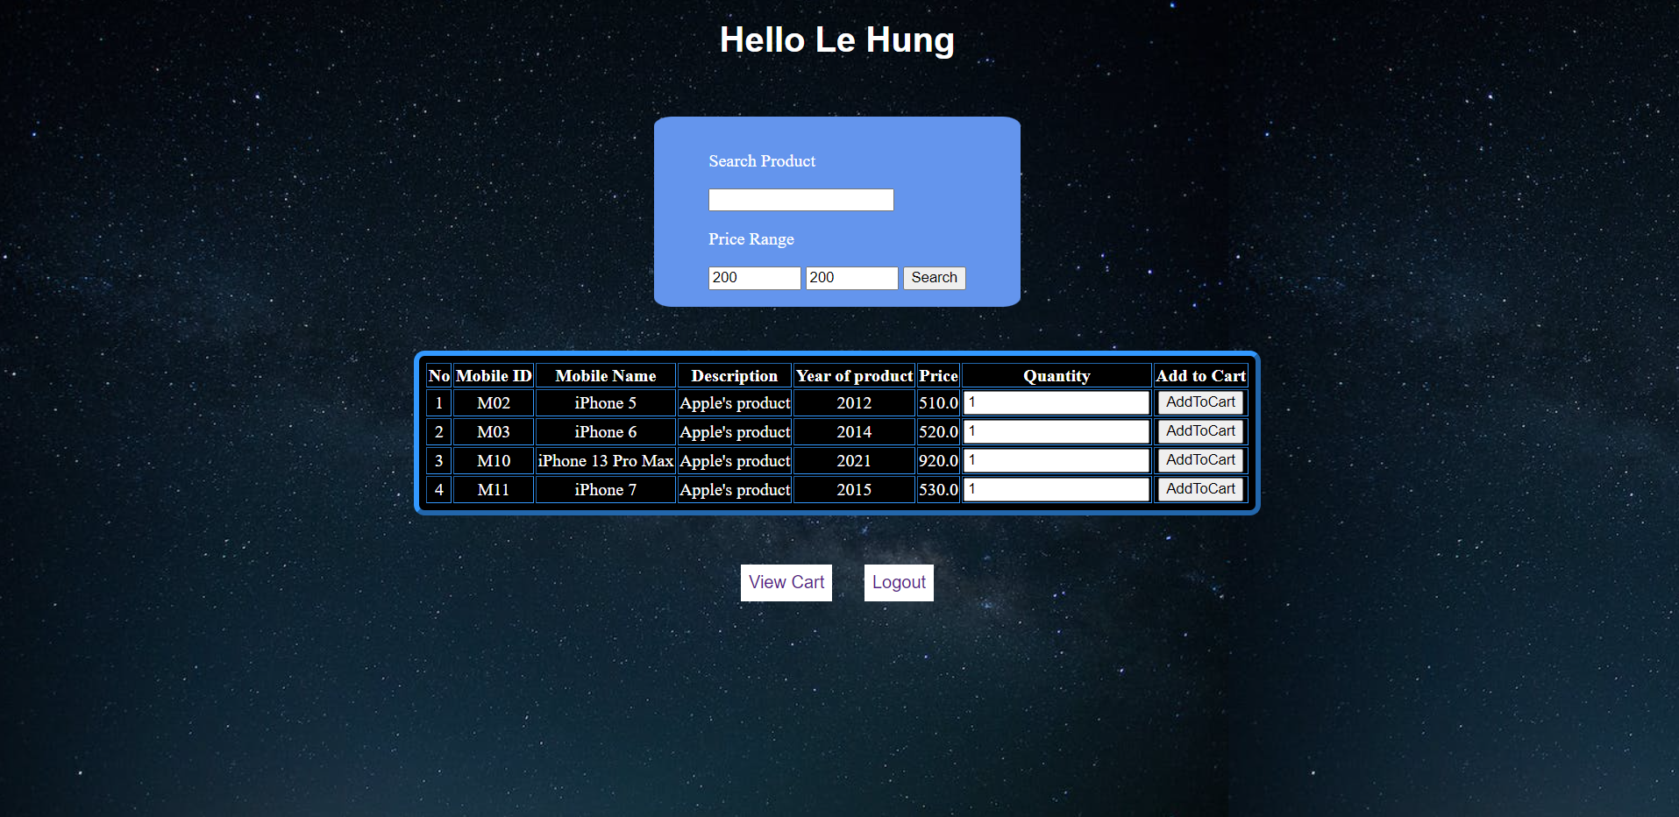

## 6. Show list of mobile

* Function trigger: press AddToCart button
* Function description: add mobile to cart

Screen layout:

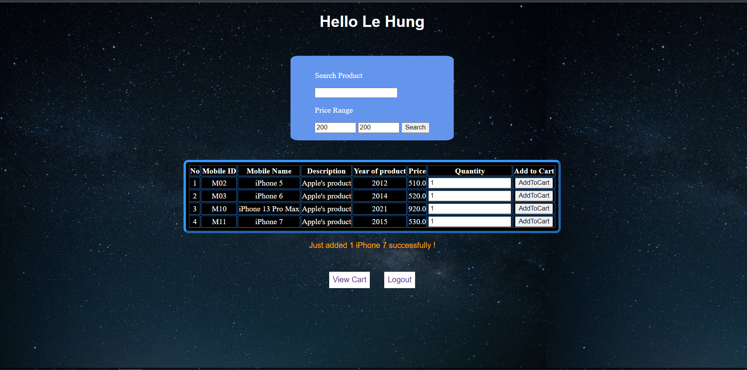

## 7. View Cart

* Trigger: press the ViewCart button
* Screen layout: 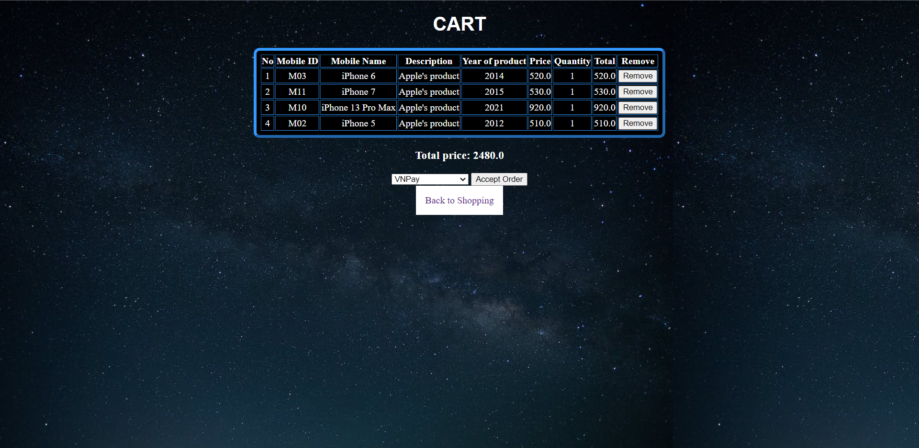

## 8. Choose payment method

* Function trigger: click on payment method list
* Function description: display payment method
* Screen layout:
* 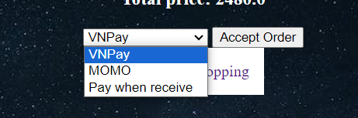

## 9 Notice of successful order

* Function trigger: after clicking Confirm Order
* Function description: a success message is displayed on the confirm Check out
* Screen layout:

